Please complete this form by Ticking treatment requirements – Incomplete referrals will be returned.
Please email: studentdentalfacility@tees.ac.uk
Fax: (01642) 384105
Post: Teesside University, Dental Reception, School of Health & Social Care, Centuria South, Middlesbrough, Tees Valley, TS1 3BA.

Please enclose radiographs to support your referral to assist in our diagnosis/treatment (as per BSP guidelines)

Title: | Forename: Surname:
Address of patient:
Postcode: |  | Date of Birth:
 Home tel: |  | Mobile:
Medical History (Please indicate any relevant and current medical history, including any known allergies Latex, CHX etc)

Previous Dental History (Please indicate patient compliance, any previous perio treatment, oral cancer diagnosis etc ).
Does the patient have any additional needs that may need further support? (e.g. dental anxiety, ADHD)
Interpreter needed: YES/ NO

If Yes, specify language ………………………………………………

.
Diagnosis: |  |  |  |  | BPE:
Local Anaesthetic Prescription – Tick X2 as Appropriate (Providing more than one option to allow for changes in MH)

Maximum Dosage per appt : 1 2 3 4 5 Route: Infiltration IDB
Lidocaine 2%, epinephrine  1:80,000  2.2ml cart  Tick: | Scandonest - Mepivacaine 3% Plain  2.2ml cart  Tick: | Citanest - Prilocaine 3%  with felypressin  2.2ml cart  Tick: |  | Articaine 4%  with epinephrine  1:100,000 , 2.2ml cart (Infil Only)  Tick: |  | Brand: Oraquix Gel  25% Lidocaine  25% Prilocaine  (intra-pocket anaesthesia)  Tick:
Dental Hygiene Treatment (Delete treatment NOT required)
All courses of treatment includes recording of appropriate indices, oral hygiene instruction, smoking cessation if required and advice relating to diet
Routine Scale & Polish (Airpolishing*)  BPE 0 – 2  *if clinically suitable/necessary |  |  | Non Surgical Periodontal Treatment (RSD)  Up to and includes a BPE 3 or 4*  *if clinically suitable/necessary  Including localised delivery of antimicrobials as required
Standard recall period to the student dental facility for maintenance visits is set at 3/12 unless otherwise stated by GDP.
This request is valid for up to 2 years from the date of this prescription
Dental Restorative Treatment
All courses of treatment include; oral hygiene instruction, smoking cessation if required and advice relating to diet and the teeth will be restored with the material we deem most appropriate unless stated otherwise.

Please state required treatment from list below and also note on chart below:
Restorative Class I-V / Fissure Sealant / Microabrasion / Deciduous Extractions / Stainless Steel Crowns / Deciduous Pulpotomies

Please use notation to chart required treatment below
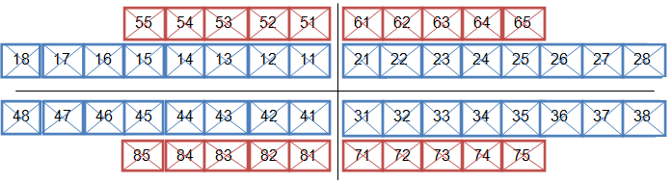

Fluoride Varnish Application Recall Period for Fluoride Varnish: 3/12 6/12

Signature of referring Dentist:  __________________________________  Printed Name:  __________________________________  Date:  Practice E-mail: | Practice stamp: (Essential)  Practice Telephone No:

